**Characteristics of Life[1]**

**1.** Biology is the study of living things. Based on what you already know, what characteristics are shared by all types of living things, including bacteria, plants and animals? What characteristics distinguish living things from non-living things?

To learn more, you will view two videos, both with the title, “Characteristics of Life”. The first video is simpler and provides a useful introduction. View this video at <https://www.youtube.com/watch?v=0NnFhY_STFQ>.

**2.** In this table, name and give an example of as many characteristics of living things as you can remember from the video.

|  |  |
| --- | --- |
| **Characteristics of Living Things** | **Example** |
|  |  |
|  |  |
|  |  |
|  |  |
|  |  |
|  |  |
|  |  |

The second video provides more information about the characteristics of living things and introduces some problems that biologists run into when they try to decide what is living and what is non-living. View this video at <https://www.youtube.com/watch?v=cQPVXrV0GNA>.

**3.** After you watch the second video, complete the table in question 2.

**4**. Each figure in this question illustrates at least two of the characteristics of living things. For each figure, explain how the figure illustrates two or more characteristics of living things.

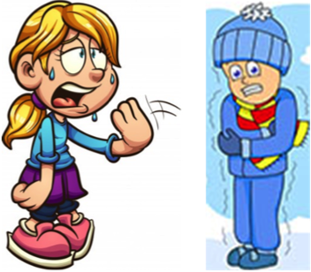

(Question 4 is continued on the next page.)

(Question 4, continued)

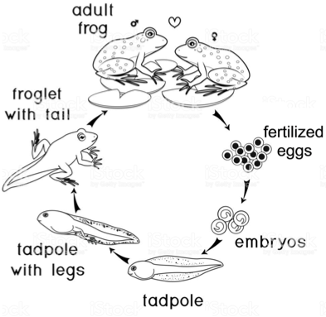

-----------------------------------------------------------------------------------------------------------------------------

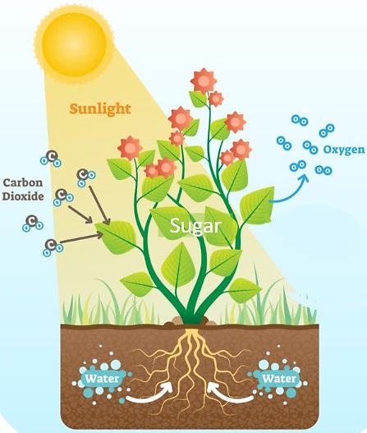

----------------------------------------------------------------------------------------------------------------------------

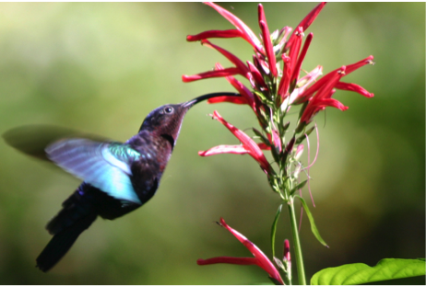

(Question 4 is continued on the next page.)

(Question 4, continued)

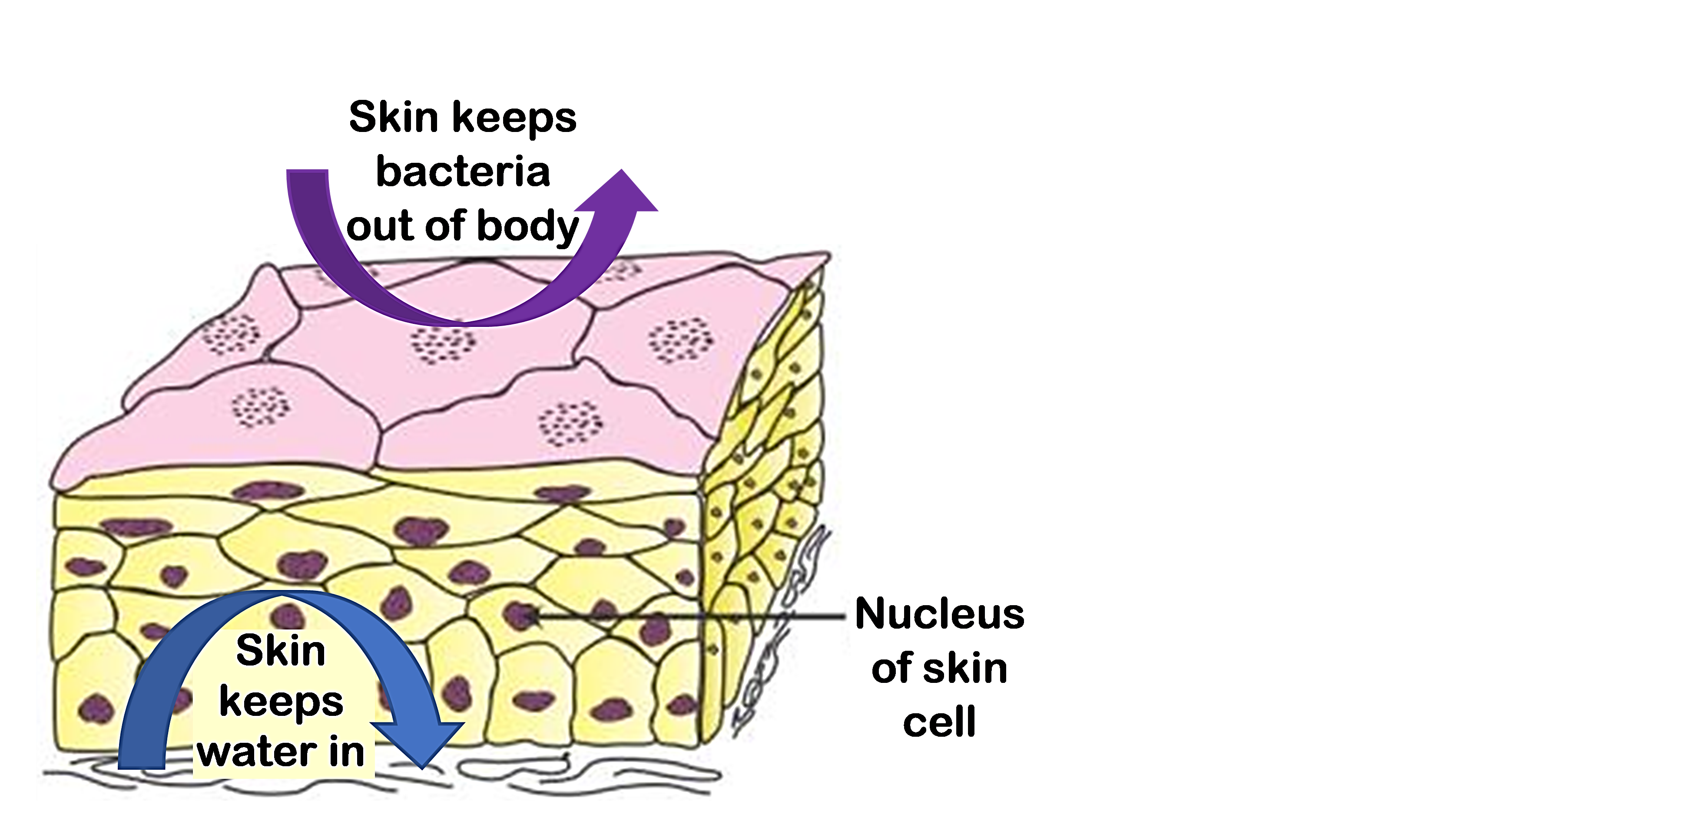

This figure shows a highly magnified view

of a cross-section of human skin.

----------------------------------------------------------------------------------------------------------------------------

**5**. Some non-living things have one or more of the characteristics of living things. Give two examples.

Some things that are clearly alive lack one or two of the characteristics of life. Consider a mule, which has a horse mother and a donkey father. Mules cannot reproduce. Therefore, mules have not evolved. However, mules have all the other characteristics of life, and they are universally accepted as living things.

Viruses lack many of the characteristics of life. For example, viruses don’t grow, maintain homeostasis, use energy, or have cells. However, viruses do have some of the characteristics of life. For example, viruses can reproduce, although only by invading a cell and using its molecules and organelles. Also, viruses have evolved adaptations. Scientists disagree about whether viruses are living things or non-living things. Some scientists argue that viruses are intermediate between living and non-living things.

|  |  |  |  |  |
| --- | --- | --- | --- | --- |
| **6a.** Check off each characteristic of a mule, a thermostat that controls a heating and cooling system, or a virus. Indicate any question with a ✓? | Characteristics of Living Things | Mule | Thermostat | Virus |
| Can grow and develop |  |  |  |
| Can reproduce |  |  |  |
| Has evolved adaptations |  |  |  |
| Maintains relatively constant conditions |  |  |  |
| Uses energy |  |  |  |
| Has one or more cells |  |  |  |

**6b.** If some living things lack one or two of the characteristics of living things and

some non-living things have one or two of the characteristics of living things,

how can we distinguish living things from non-living things?

**6c.** If you use the criteria for living things in your answer to question 6b, are viruses alive?

1. By Dr. Ingrid Waldron, Department of Biology, University of Pennsylvania © 2024. This Student Handout and Teacher Notes with instructional suggestions and biology background are available at [https://serendipstudio.org/exchange/bioactivities/lifecharacteristics](%20https:/serendipstudio.org/exchange/bioactivities/lifecharacteristics).